Reflective journal –

09/06/2026 16:26
On my quest to better understand bittersweetness and to design for a blend of joyful and sorrowful emotions, I’ve been drawing on games and other media for inspiration. If I know how this feeling is elicited, or rather, if I can start to understand the triggers behind this emotional payoff, I can take those triggers and design an interactive experience with them.
I’ve begun this journey by consulting my colleague, Dave Pimm, on the idea of designing for bittersweetness. He just finished teaching a class on this very topic and has shown me the study material he provided his students. I started my research with the video, “The Life of Chuck” which depicts two characters admiring the stars before those stars begin to slowly disappear, signifying that something sinister is about to unfold. The two share a short conversation with one another, sharing knowledge of space and appreciating the beauty of the night sky. This is reinforced in their emotional reactions of tearing up throughout the conversation. I appreciate this emotional response as I often feel the same when I look up at the night sky. I usually take the bins out at an unusually ungodly hour, but that time of night (or morning…) is so peaceful, with almost no light pollution. It’s at these moments where I just stop and gaze up at the night sky, breathe in the cool night air, and appreciate the stillness that surrounds me. Looking straight up at the night sky evokes a feeling of calmness in me, but also a slight unease as I begin to comprehend the vastness of space. It is incomprehensible and utterly awe inspiring.
In the study materials I came across some articles on this concept of awe and they all draw on similar themes. Piff et al., 2015 discuss the hypothesis that awe as a collective emotion can increase prosocial behaviour, with Keltner and Haidt (2003) regarding awe as a spiritual emotion that makes use feel connected. This is possibly an avenue I want to traverse with my game as a possible tool to make the characters in my game feel connected (and subsequently, the player experience this vicariously). There’s a highly cited research paper by Shiota, Keltner and Mossman (2005) into the elicitors of awe which I will study later to help me design for this. It should be noted that the video was prefaced with the fact that the two characters, Marty and Felicia, were once married, and this is the last moment they spend together. A notable moment is when Marty offers his hand to Felicia, which, in the context of this scene, could signify forgiveness or could be an act of compassion. This paper by Goetz, Keltner and Simon-Thomas (2010) expands the idea of touch slightly by explaining that caregiving behaviours resemble displays of compassion. In my own life experience, I feel this is correct. When a loved one is upset, I often feel compelled to hold them or stroke them. From this one video, I have two potential tools that I can lean on in my own designs toward a bittersweet emotional payoff.
10/06/2026 9:59am
Looking further through the study materials I came across a term that stuck out to me: saudade, which describes the deep, nostalgic longing for something or someone beloved, often in the knowledge it may never return. This resonates with me as the style of game I want to create may involved a loved one that has died, and the player-character is remembering them. Combining this with touch, I think I have two core design tools to incorporate into my game loop: the feeling of saudade and the interactivity of touch. Keltner describes touch as a method for reducing stress, fostering cooperation and improving health. Perhaps I can lean on this as a core mechanic. For example, holding onto a teddy bear as a way to reduce the stress of the player character. The game Ico has a holding hands mechanic which fosters cooperation, although I’m not sure how I can design for that right now given the single character focus.
To help me focus, I’ve put this video on in the background
Design thoughts:
Experiential goal: evoke a bittersweet feeling. Player-character is a father recollecting memories of his son.
Verbs: touch, listen
Core mechanic: holding/hugging a toy, listening to audio clips
Camera angle: 3rd person. I think it could be a really interesting perspective if the camera is angled up, almost as if a child is looking up at the player-character, and having the player navigate the space from that perspective. I want to capture the feeling that the player-character is being observed, with subtle explicit hints. For example, if the player-character is facing his son’s door and then walks out of shot, the camera lingers for a brief moment before rotating toward the player-character. In essence, the camera becomes a character. This might make hugging the toy harder to pull off simply because the player wont see it properly.
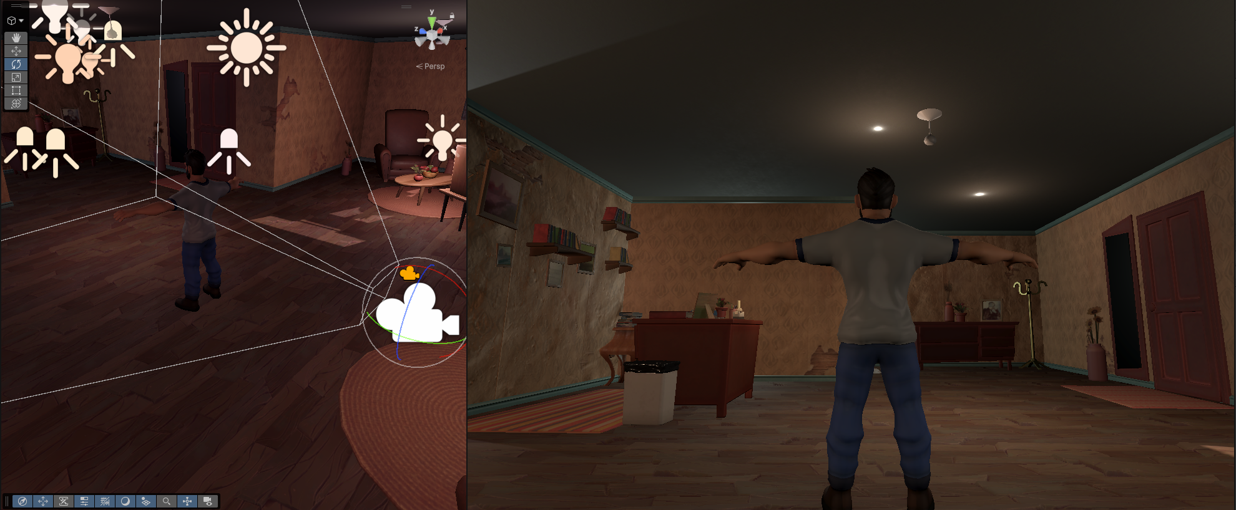
I downloaded some premade assets and experimented with the camera angle in-engine and it seems okay in the sense that I can still largely see the play space.
11/06/2026 9:19am
This morning I have been thinking about how to explicitly design for saudade and to integrate this into a moment to moment action. My first thoughts were in relation to tidying the house of the son’s toys scattered on the floor. While this is an action, I also feel like this doesn’t really touch on the idea of desiring something that can no longer exist. Maybe I can instead lean on trying to structure the house on a future that doesn’t exist instead. So picking up toys and placing them in a way that’s ready to be played with.
“you were the best dad”

